
Junior Suite Ocean View
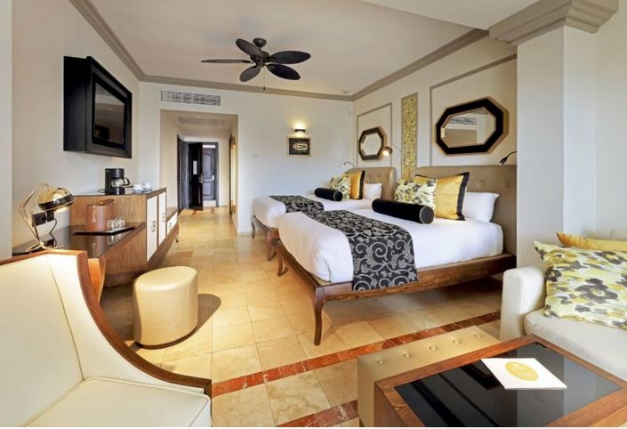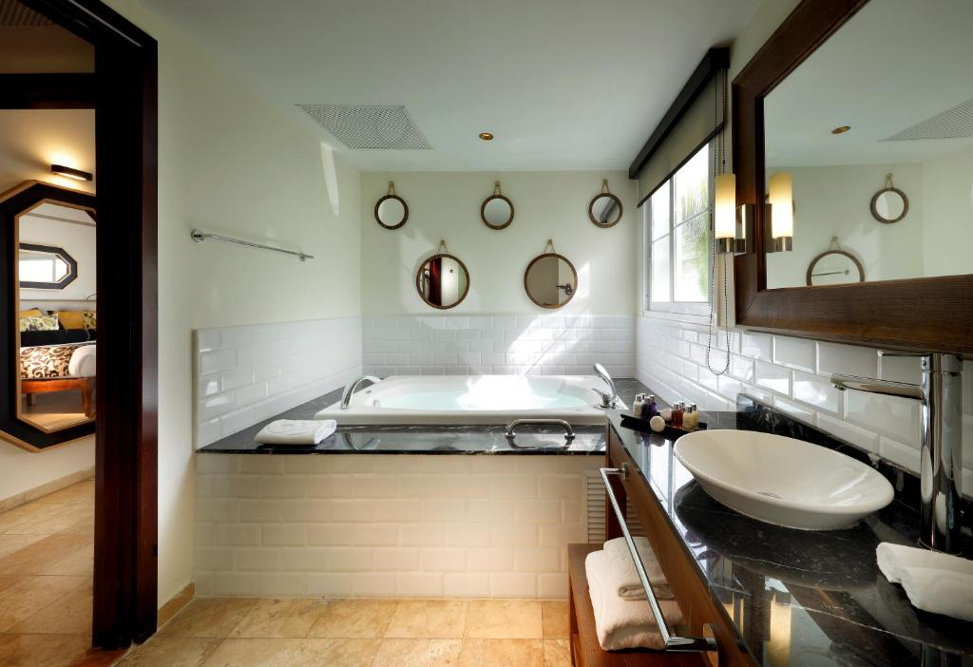
- 570 sq ft
- King or 2 beds Sleeps - 3
Modern room with magnificent views of the turquoise waters of the Caribbean Sea.
Treat yourself to an unforgettable experience in this comfortable room with a marble hydromassage bath and a furnished terrace.
This room is available with either one king bed or two full beds – we’ll do our best to accommodate your preference.
- Memory foam mattresses
- Hydromassage bathtub
- Sofa bed
- Flat screen TV in living room
- Terrace
- Minibar
- Bathrobe & slippers
- Electronic safe
- Steam iron
- Facilities for tea and coffee
- Bath amenities
- Hair dryer
- Wifi
- Mirror with magnification
- Black out curtains

