
Junior Suite Garden View
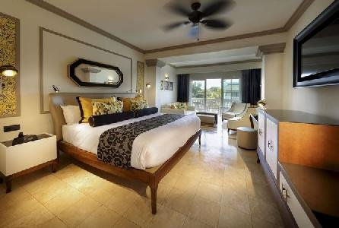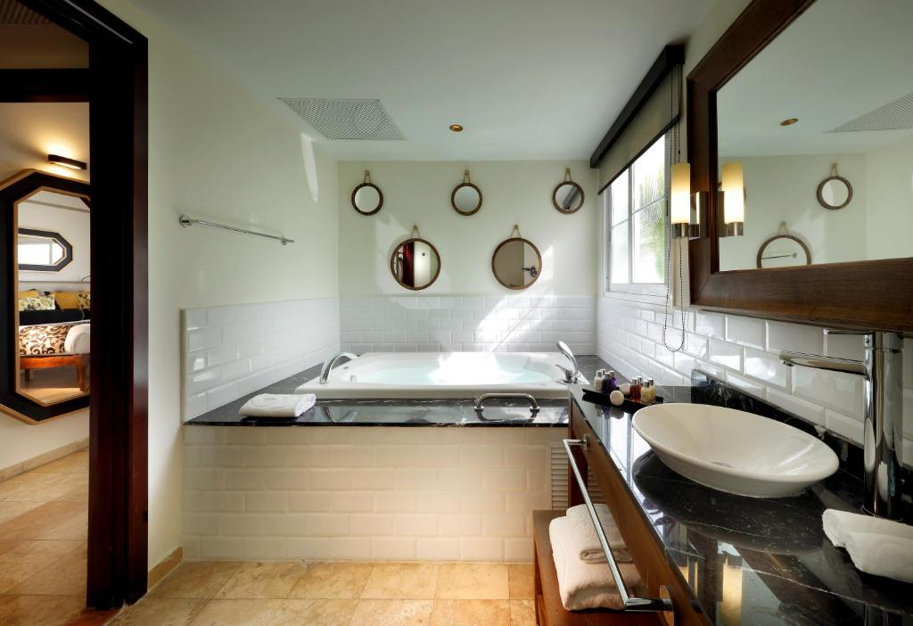
- 570 sq ft
- King or 2 beds Sleeps - 3
Fabulous room with modern decor overlooking tranquil tropical gardens.
Have the experience of a lifetime in Montego Bay in this comfortable room with a cozy furnished terrace – the perfect place to unwind with a cold drink in hand.
This room is available with either one king bed or two full beds – we’ll do our best to accommodate your preference.
- Memory foam mattresses
- Hydromassage bathtub
- Sofa bed
- Flat screen TV in living room
- Terrace
- Minibar
- Bathrobe & slippers
- Electronic safe
- Steam iron
- Facilities for tea and coffee
- Bath amenities
- Hair dryer
- Wifi
- Mirror with magnification
- Black out curtains

