
Romance Villa Suite
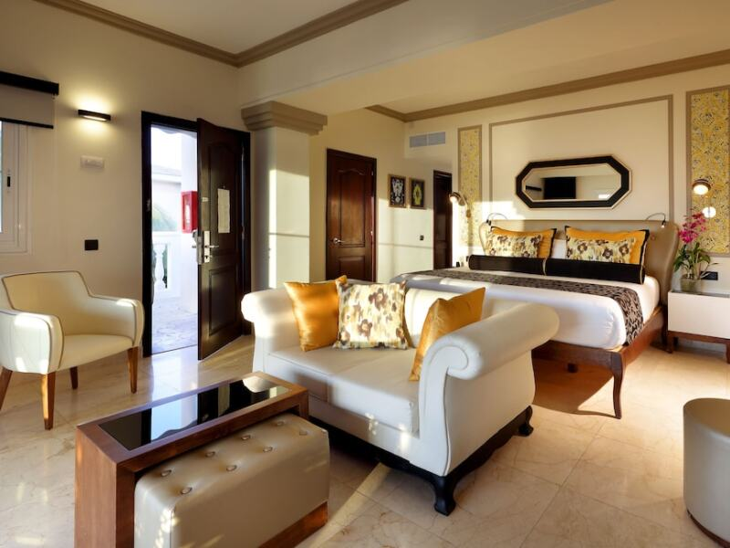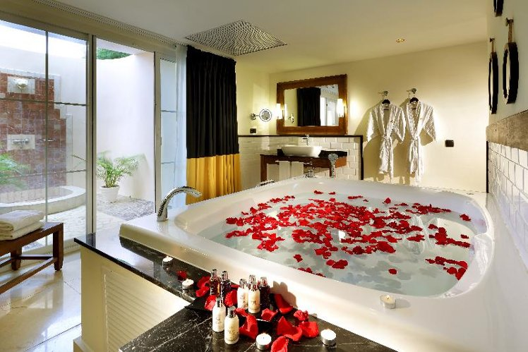
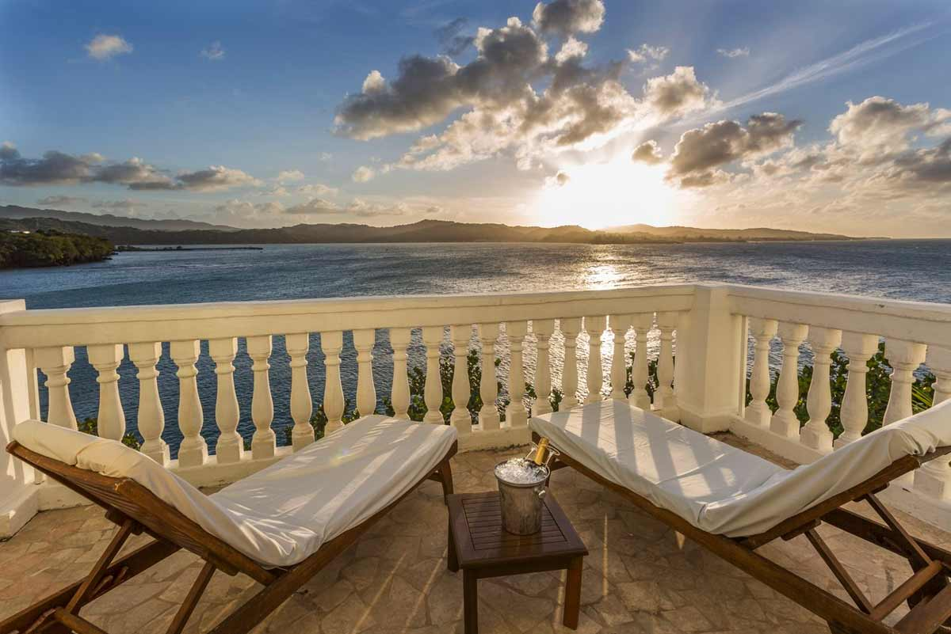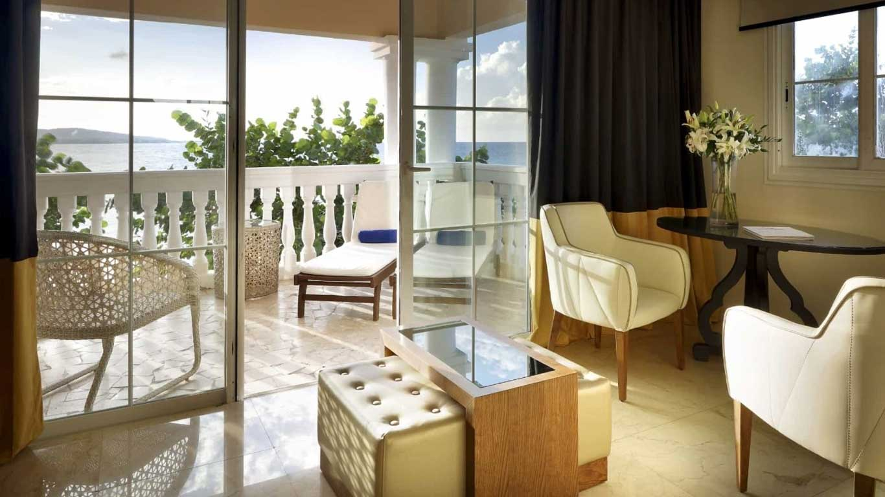
- 895 sq ft
- King
Spacious adults-only suite far from the buzz of the bars with breathtaking views and a private outdoor shower. The pinnacle of romance.
This modern suite has everything you need for an unforgettable romantic getaway: a private entrance, a hydromassage bath for two, and a large terrace with a sitting area and sunbeds.
Indulge in a vacation you’ll never forget in a slice of Caribbean paradise.
- Memory foam mattresses
- Hydromassage bathtub
- Sofa bed
- Flat screen TV in living room
- Terrace
- Minibar
- Bathrobe & slippers
- Electronic safe
- Steam iron
- Facilities for tea and coffee
- Bath amenities
- Hair dryer
- Wifi
- Mirror with magnification
- Black out curtains

